**Unlocking Insights with Forecasted Sales: Tech Innovators Inc Case Study.**



In an increasingly competitive market, forecasting is pivotal in empowering businesses to make data-driven decisions. Using a combination of simple linear regression and seasonal adjustment techniques, alongside other forecasting methods, the provided analysis offers fascinating insights into tablet sales trends spanning three years. Here is the story behind the data.

**Understanding the Data**

The dataset captures monthly tablet sales from January 2020 to December 2022. The methodology employed combines:

* **Simple Linear Regression (SLR)** to establish a baseline trend in sales.
* **Seasonality Index Adjustment** to account for periodic fluctuations in demand across months.
* **Linear Forecasting** to model future sales by extending historical trends.
* **Moving Average Analysis** to smooth out short-term fluctuations and highlight longer-term trends.
* **Exponential Smoothing** to give more weight to recent observations while accounting for trends and seasonality.
* **Naive Approach** as a benchmark method, assuming future sales will be equal to the most recent observation.

**Key Observations**

1. **Steady Growth in Baseline Sales:** The linear regression analysis reveals a steady upward trend in sales over the observed period, with an intercept of 9640.47 and a slope of 9.64. This indicates a consistent increase in demand, albeit at a gradual pace.
2. **Seasonality Patterns:** A detailed seasonality index table highlights pronounced fluctuations in sales, with months like March and October consistently outperforming others. The seasonality index provides a multiplier for forecasting, ensuring that the model adapts to these patterns.
3. **Linear Forecasting Insight:** Linear forecasting extends historical sales trends into the future, providing a straightforward projection. While effective for capturing long-term trends, it may overlook short-term variations.
4. **Moving Average Analysis:** The moving average method reveals smoothed sales trends by averaging values over a defined period. This approach highlights the underlying pattern and minimizes the impact of irregularities.
5. **Exponential Smoothing Results:** Exponential smoothing incorporates recent sales data more heavily, allowing for dynamic adjustments to trends and seasonal variations. This method demonstrated strong alignment with actual sales, making it particularly valuable for capturing shifts in consumer behaviour.
6. **Naive Approach Observations:** While simplistic, the naive approach provides a quick benchmark by assuming that sales in the next period will equal those of the current period. Its simplicity highlights the effectiveness of more sophisticated methods when deviations from this baseline are observed.
7. **Accuracy Metrics:** Performance evaluation metrics such as MAE (Mean Absolute Error), MSE (Mean Squared Error), and MAPE (Mean Absolute Percentage Error) demonstrate the accuracy of the forecast model. With a MAPE of 13%, the predictions align closely with actual sales trends, reflecting high reliability for business planning.

**Visualising the Results**

The charts included provide a visual narrative:

* **Simple Linear Regression:** The blue line represents actual sales, while the orange line tracks baseline predictions. Though the regression captures the overall trend, deviations highlight the need for seasonal adjustments. With the most preferred forecast at 94% accuracy.
* **Seasonally Adjusted Forecasts:** The adjusted forecast closely mirrors actual sales, capturing peaks and troughs accurately at 87%. This refinement bridges the gap between statistical modelling and real-world applicability.

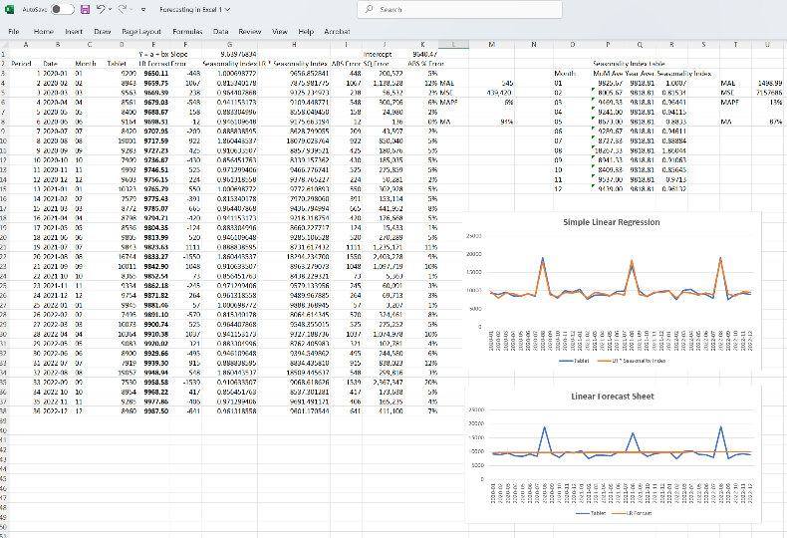

* **Moving Average and Exponential Smoothing:** These methods smooth out irregularities and align closely with sales trends, with exponential smoothing being particularly effective in adapting to changing patterns at 80%.

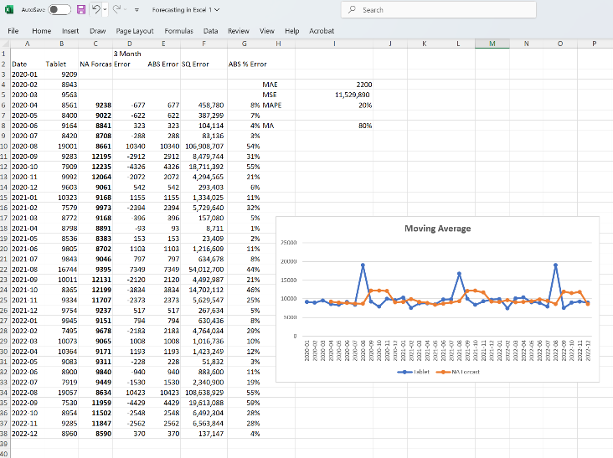 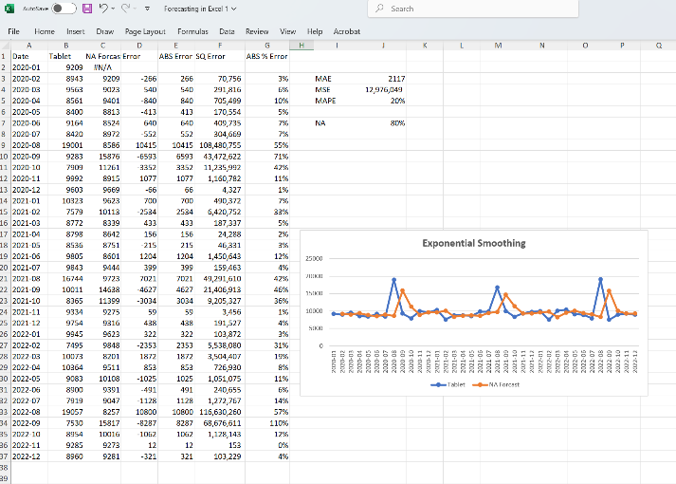

* **Naive Approach:** While straightforward, the naive forecast falls short in accounting for seasonality and long-term trends, underscoring the value of more advanced methods at 78%.

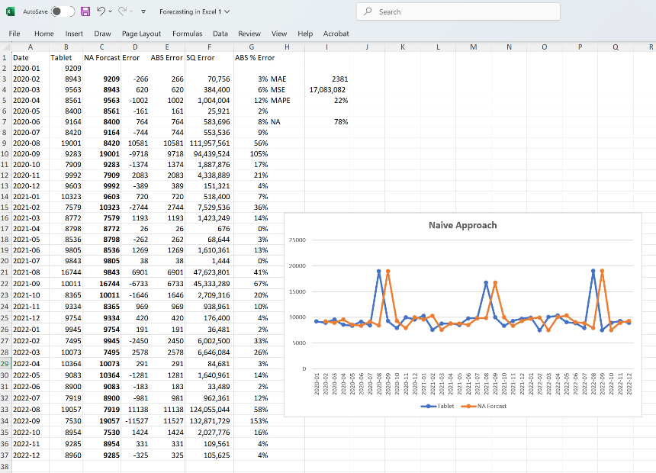

**Strategic Implications**

This analysis equips Tech Innovators Inc. with actionable insights:

1. **Inventory Management:** With accurate forecasts, Tech Innovators Inc. can optimize inventory levels, avoiding stockouts during peak months and minimizing excess inventory during slower periods.
2. **Marketing Campaigns:** Insights into seasonal demand surges enable targeted promotions during high-demand months, maximising revenue potential.
3. **Budget Planning:** Reliable forecasts support precise budget allocations across departments, enhancing overall operational efficiency.
4. **Method Selection for Specific Needs:** The choice of forecasting method depends on the business’s focus, whether it’s long-term trend prediction (Linear Regression), seasonal adaptation (Exponential Smoothing), or smoothing short-term noise (Moving Average).

**Conclusion**

The fusion of simple linear regression, seasonality adjustment, and complementary forecasting techniques has unlocked a deeper understanding of sales dynamics at Tech Innovators Inc. As the business landscape grows increasingly complex, leveraging predictive analytics tools such as these will remain indispensable for staying ahead in the market.

This journey of translating raw data into strategic insights is a testament to the power of analytics in driving informed decision-making and fostering growth. By refining models further with additional variables such as marketing efforts, economic indicators, or competitor dynamics, the potential for precision becomes boundless.

**Kindly share your feedback and I am happy to Connect** 🌟

